Telecom Customer Churn Analysis

Project Overview
This project analyzes customer churn behavior in a telecom company using Python, Exploratory Data Analysis (EDA), and Machine Learning.
The primary objective was to identify patterns associated with customer churn and develop predictive models capable of identifying high-risk customers.
Unlike a basic beginner notebook, this project combines:
- Business-oriented EDA
- Data preprocessing and feature engineering
- Multiple machine learning models
- Model comparison using ROC-AUC
- Threshold optimization
- Feature importance analysis
- Model persistence using Joblib

Business Objective
Telecom companies face major revenue losses due to customer churn. Since retaining customers is more cost-effective than acquiring new ones, understanding churn behavior is critical.
The project focuses on:
- Identifying churn-related customer behaviors
- Understanding service and contract-based churn patterns
- Building predictive models for churn detection
- Evaluating model performance using classification metrics

Dataset Information
Dataset Used:
Telco_customer_churn.csv
The dataset contains customer demographic details, subscribed services, payment information, tenure history, and churn labels.

Important Variables
Variable | Description
Tenure Months | Customer relationship duration
Monthly Charge | Monthly billing amount
Total Charges | Lifetime spending
Contract | Contract type
Internet Service | Internet subscription type
Payment Method | Billing/payment method
Tech Support | Availability of support services
Online Security | Security subscription
Churn Label | Target variable

Technologies Used
- Python
- Pandas
- NumPy
- Matplotlib
- Seaborn
- Scikit-learn
- XGBoost
- Imbalanced-learn (SMOTE)
- Joblib
- Jupyter Notebook

Data Cleaning and Preprocessing
The dataset required several preprocessing steps before analysis and modeling.

Cleaning Steps Performed
- Converted Total Charges from object to numeric datatype
- Removed rows with missing Total Charges
- Removed duplicate records
- Dropped unnecessary columns such as:
  - CustomerID
  - Churn Reason
- Created binary target variable:
df["churn"] = df["Churn Label"].map({"Yes":1, "No":0})

Exploratory Data Analysis (EDA)
EDA was conducted to identify churn behavior patterns and business trends.

1. Overall Churn Distribution
A pie chart was created to visualize overall churn percentage within the customer base.

Observation
The dataset shows a noticeable imbalance between churned and retained customers.
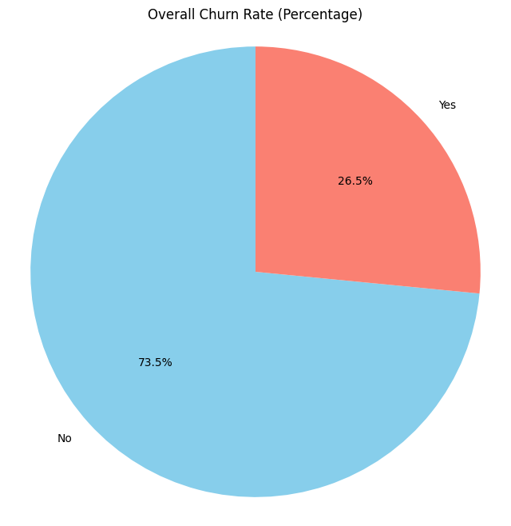

2. Contract Type vs Churn
A countplot was used to compare churn behavior across contract types.

Observation
Customers with month-to-month contracts showed significantly higher churn compared to yearly contracts.
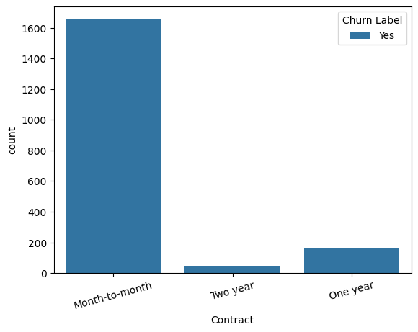

3. Tech Support vs Churn
Customers without technical support services demonstrated higher churn behavior.

Observation
Lack of support services may reduce customer retention.
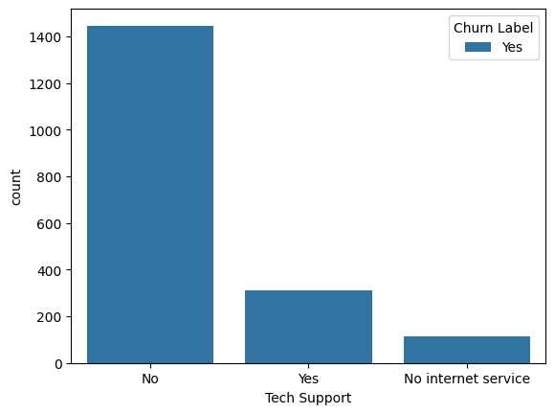

4. Online Security vs Churn
Customers without online security subscriptions churned more frequently.

Observation
Additional service adoption appears correlated with customer retention.
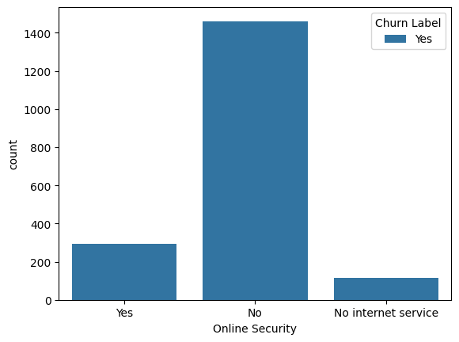

5. Senior Citizen vs Churn
EDA was conducted to analyze churn behavior among senior citizens.

Observation
Customer demographics may influence churn trends and service expectations.
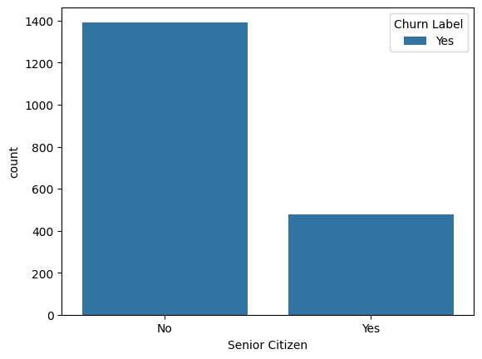

6. Payment Method Analysis
Cross-tab analysis and visualizations were used to evaluate payment methods.

Observation
Certain payment methods demonstrated relatively higher churn frequencies.
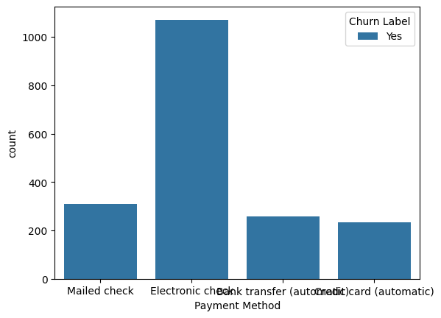

7. Internet Service Analysis
Internet service categories were analyzed against churn labels.

Observation
Internet subscription type showed meaningful differences in churn behavior.
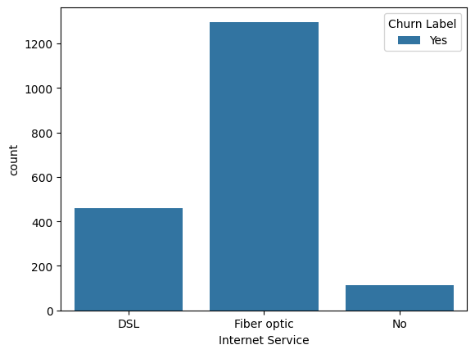

Feature Engineering
Additional engineered features were created to improve predictive performance.

Engineered Features

Average Monthly Revenue
avg_monthly_revenue = Total Charges / Tenure Months
This feature estimates customer revenue generation relative to account age.

Service Bundle Count
A service bundle feature was created using multiple subscribed services.
This acts as a proxy for customer stickiness and ecosystem dependency.

Predictive Modeling
Multiple machine learning models were trained and evaluated.

Models Used
Model | Purpose
Logistic Regression | Baseline interpretable model
Random Forest | Ensemble learning model
XGBoost | Gradient boosting classifier

Handling Imbalanced Data
The churn dataset was imbalanced.
To improve model performance on minority churn cases, SMOTE (Synthetic Minority Oversampling Technique) was used inside the machine learning pipeline.

Preprocessing Pipeline
A preprocessing pipeline was implemented using:
- StandardScaler for numerical features
- OneHotEncoder for categorical features
- ColumnTransformer for combined preprocessing
This ensures consistent and reproducible model training.

Model Evaluation Strategy
Models were evaluated using:
- 5-Fold Cross Validation
- ROC-AUC Score
- Precision
- Recall
- F1-Score
- Confusion Matrix
- Precision-Recall Curve

Cross-Validation Results
Model | CV ROC-AUC
Logistic Regression | 0.8443
Random Forest | 0.8413
XGBoost | 0.8626

Observation
XGBoost achieved the strongest cross-validated ROC-AUC performance among all tested models.

Hold-Out Test Performance

Logistic Regression Performance
Metric | Score
Accuracy | 0.75
ROC-AUC | 0.8277
Churn Recall | 0.74
Churn F1-Score | 0.61

Interpretation
The model performed reasonably well in identifying churn customers while maintaining balanced recall and precision.

ROC Curve Analysis
ROC curves were generated for all trained models to compare classification capability.
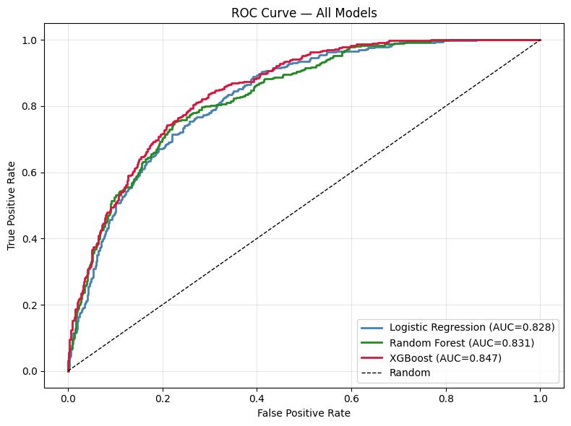

Observation
XGBoost produced the strongest overall discrimination performance.

Feature Importance Analysis
Feature importance analysis was performed using the best-performing model.
The analysis helped identify the most influential variables affecting churn prediction.
This improves interpretability and business understanding.
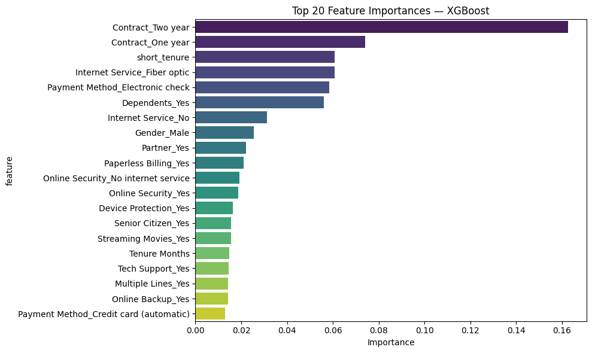

Threshold Optimization
Instead of relying solely on the default probability threshold (0.5), threshold tuning was performed to optimize F1-score.
This is important in churn projects because identifying churn customers accurately is often more valuable than maximizing raw accuracy.
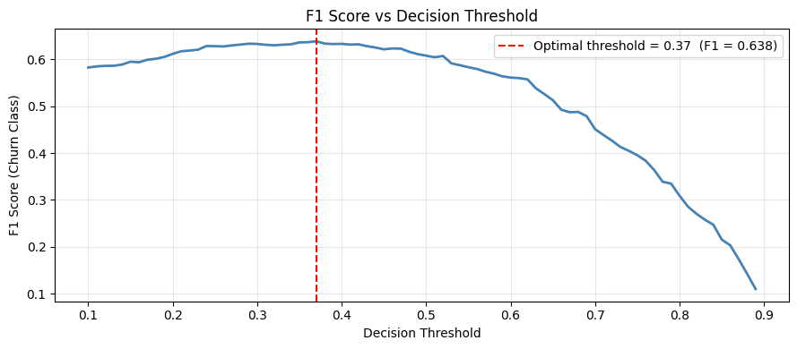

Precision-Recall Curve
A Precision-Recall curve was generated for the best-performing model.
This provides better evaluation for imbalanced classification problems where churn customers represent the minority class.
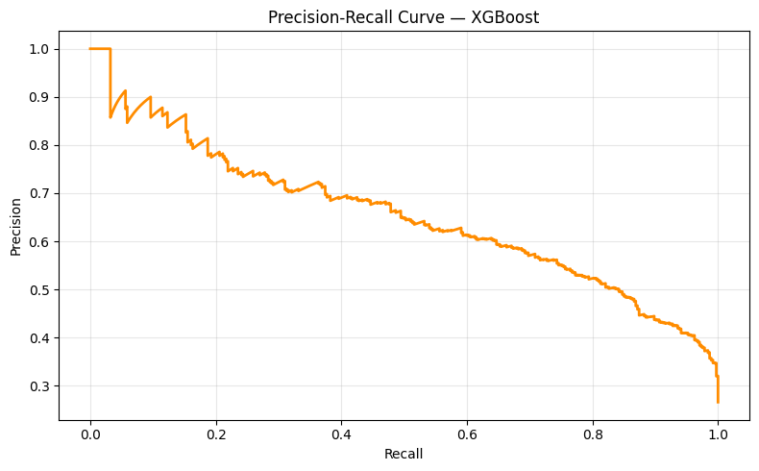

Model Persistence
The final trained model was saved using Joblib.
joblib.dump(best_pipe, "churn_best_model.joblib")
This allows future deployment and inference without retraining.

Key Technical Highlights
This project demonstrates practical industry-level machine learning workflow elements including:
- Feature engineering
- Data preprocessing pipelines
- SMOTE balancing
- Multiple model comparison
- Cross-validation
- ROC-AUC evaluation
- Threshold tuning
- Feature importance analysis
- Model serialization

Conclusion
This project demonstrates a complete end-to-end telecom churn analysis workflow using Python and machine learning.
The analysis combines business-focused EDA with advanced predictive modeling techniques to identify customer churn patterns and evaluate classification performance.
Among the tested models, XGBoost achieved the strongest overall performance based on ROC-AUC evaluation.
The project also highlights the importance of:
- Proper preprocessing
- Feature engineering
- Imbalanced data handling
- Evaluation beyond simple accuracy
Overall, the project reflects a practical portfolio-level implementation of customer churn analytics.

Author
Farhan Rahman Fahim
Aspiring Data Analyst | Python & Business Analytics Enthusiast

